DRIVER-RIDER COST-SHARING STRATEGIES AND EQUILIBRIA IN A RIDESHARING PROGRAM

Author Name1*, Author Name 2 and Author Name3

*1 Department, University, City, Country*

*2 Department, University, City, Country*

*3 Department, University, City, Country*

**Abstract:** The rapid development of smartphone technology has led to the increased popularity of dynamic ridesharing apps used to organize ad hoc ridesharing trips between strangers on short notice. …

**Keywords:** ridesharing; cost-sharing mechanism; …

Name of presenter/key speaker:

|  |
| --- |
|  |

Submission for CTS Outstanding Paper Award (You are needed to submit full paper): (Please put a “X” as appropriate)

|  |  |  |  |
| --- | --- | --- | --- |
|  | Yes |  | No |

DRIVER-RIDER COST-SHARING STRATEGIES AND EQUILIBRIA IN A RIDESHARING PROGRAM

Author Name1[1]*, Author Name 2 and Author Name3

*1 Department, University, City, Country*

*2 Department, University, City, Country*

*3 Department, University, City, Country*

**Abstract:** The rapid development of smartphone technology has led to the increased popularity of dynamic ridesharing apps used to organize ad hoc ridesharing trips between strangers on short notice. …

**Keywords:** ridesharing; cost-sharing mechanism; …

# Introduction

Ridesharing, defined as two or more people with similar routes and schedules sharing one car, is widely considered an effective and efficient way to conserve fuel, mitigate congestion, and reduce emissions. …

Organized ridesharing has a long history in private car-oriented countries. The first ridesharing program, Car-Sharing Club, dates back to World War II and was organized by the United States government to conserve fuel (Furuhata et al. 2013). The prevalence of ridesharing in the United States peaked in the 1970s as a result of the oil crises. According to the U.S. Census, 20.4% of American workers commuted to work by ridesharing in the 1970s (Chan and Shaheen 2012).

# Model

**2.1. Preliminaries**

Consider a corridor between a residential area and a workplace as shown in Figure 1, ...

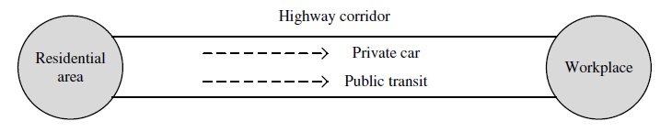

**Figure 1.** The Simple Network

For a traveler with the value of time (VOT) *β*, the travel costs of being a solo driver and public transit user are, respectively,

, (1)

and

, (2)

where  and  indicate the travel time of public transit and private vehicles, respectively….

In view of Equations (1)-(2), the expected time and non-time cost of each mode for car owners can be easily determined as shown in Table 1.

**Table 1.** Expected Travel Cost of Different Modes for Car Owners

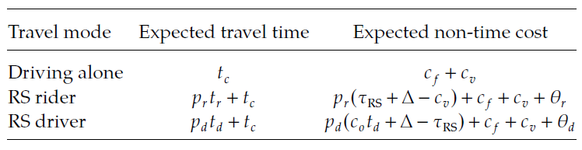

# Conclusion

This paper has shown the impacts of rider-driver cost-sharing strategies on the success of ridesharing programs …

# Acknowledgments

This study was jointly supported by grants from ...

# References

Chan ND, Shaheen SA (2012) Ridesharing in North America: Past, present, and future. *Transport Reviews* 32(1): 93–112.

Furuhata M, Dessouky M, Ordóñez F, Brunet ME, Wang X, Koenig S (2013) Ridesharing: The state-of-the-art and future directions. *Transportation Research Part B: Methodological* 57: 28–46.

1. * Corresponding author. Email address: abcd@xxxx.